Lorenz System Modeling and Visualization
Christoffer Hansen
Grand Canyon University
CST-305: Principles of Modeling and Simulation Lecture & Lab
Ricardo Citro
December 7, 2025

- Responsibilities and Completed Tasks
This project was completed independently. The following tasks were performed:
• Mathematical research and formulation of the Lorenz System
• Development of conceptual system performance description
• Drafting of the problem statement and context
• Preparation of placeholders for figures, screenshots, and implementation details
2. System Performance Context Description
The Lorenz system is used in this project to illustrate how small changes in underlying parameters can dramatically alter the behavior of a dynamic system. In the context of computer science and system performance modeling, this demonstrates how complex systems—such as distributed networks, multi-threaded programs, or resource-dependent processes—can be highly sensitive to parameter tuning, configuration errors, or slight deviations in initial input.
The interactive Lorenz attractor simulation implemented in code shows this relationship by allowing the user to adjust the three core parameters (σ, ρ, β) using slider controls. As these values change, the system trajectory responds immediately, often shifting from stable to highly chaotic behavior. This dynamic response provides a conceptual framework for understanding performance sensitivity in computing systems, where small configuration changes (e.g., memory allocation adjustments, thread scheduling differences, workload variations) may produce unpredictable performance outcomes.
The visualization therefore serves as a metaphor for evaluating system stability: stable parameter sets correspond to predictable system behavior, while chaotic regions suggest unpredictability and potential performance degradation. This context allows the mathematical Lorenz model to be applied to real computing environments by illustrating instability thresholds, tuning difficulties, and long-term unpredictability.

3. Specific Problem Being Solved
This project addresses the problem of modeling and visualizing sensitivity to initial conditions and parameter values in dynamic systems. In many real-world applications—such as climate modeling, system performance prediction, robotics, or complex simulations—understanding how small changes propagate through a system is essential.
The Lorenz system provides a mathematically valid and visually interpretable example of chaotic behavior. The problem solved here is giving the user an intuitive way to explore chaos by allowing them to:
- Run a numerical simulation of the Lorenz system,
- Adjust system parameters interactively in real time, and
- Observe how the trajectory evolves in response.
The code solves the specific challenge of demonstrating chaotic behavior in an accessible and interactive way, making it easier for students or researchers to see how unpredictable system behavior can emerge from deterministic equations. The ability to manipulate parameters enables experimentation with stability margins, attractor shapes, and the transition between order and chaos.

4. Mathematical Approach
The Lorenz system is defined by the set of coupled nonlinear differential equations:
- dx/dt = σ(y − x)
- dy/dt = x(ρ − z) − y
- dz/dt = xy − βz
These equations describe the rate of change of three variables—x(t), y(t), and z(t)—that evolve together over time. In the original meteorological context, these variables represented convection, temperature variation, and vertical motion. In this project, they serve as abstract indicators of system state evolving under sensitive dynamics.
The approach taken in the code is to solve these equations numerically. Since an analytical solution does not exist, the project uses the Fourth-Order Runge–Kutta (RK4) method to approximate the trajectory. This method is widely used for numerically solving ODEs because it provides a high degree of accuracy while maintaining reasonable computational efficiency.
At each timestep, RK4 calculates four intermediate derivative estimates (k1, k2, k3, k4) using the Lorenz equations. These are then combined into a weighted average to compute the next system state. The trajectory is built by iterating this process thousands of times.
The mathematical approach also incorporates parameter manipulation. The variables σ, ρ, and β define the system’s behavior:
- σ (sigma): Controls divergence in the x–y plane (Prandtl number).
- ρ (rho): Governs the onset of chaotic behavior (Rayleigh number).
- β (beta): Controls vertical contraction and the shape of the attractor.
By adjusting these parameters, users can explore stable regions (e.g., ρ < 24.74) and chaotic regions (e.g., ρ ≈ 28), visually reinforcing the mathematical relationship between parameter values and long-term behavior.

5. Implementation Approach (Algorithm / Flowchart)
Algorithmic Description
- Initialize parameters:
Set default values for σ, ρ, β, initial state (x0, y0, z0), total time duration, and timestep.
- Define the Lorenz equations:
Implement a function lorenz(state, sigma, rho, beta) that computes dx/dt, dy/dt, dz/dt.
- Implement the RK4 integrator:
  - Compute k1 using current state
  - Compute k2 using state + (dt/2)*k1
  - Compute k3 using state + (dt/2)*k2
  - Compute k4 using state + dt*k3
  - Update state using weighted sum:
state_next = state + (dt/6)*(k1 + 2k2 + 2k3 + k4)
- Iterate over the time range:
For each timestep, compute new system state and store coordinates.
- Plot the initial Lorenz attractor in 3D using Matplotlib.
- Create user-adjustable sliders for σ, ρ, and β:
  - When the user changes a slider, recompute the trajectory with new parameters.
  - Update the plot dynamically to show the effect in real time.
- Implement an animation effect
A timed callback updates only a segment of the trajectory to create a moving “tail” effect.
- Add a Reset button
Resets all parameters to default values.
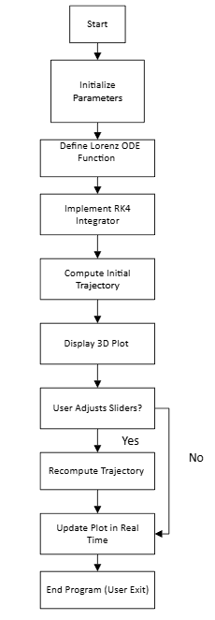

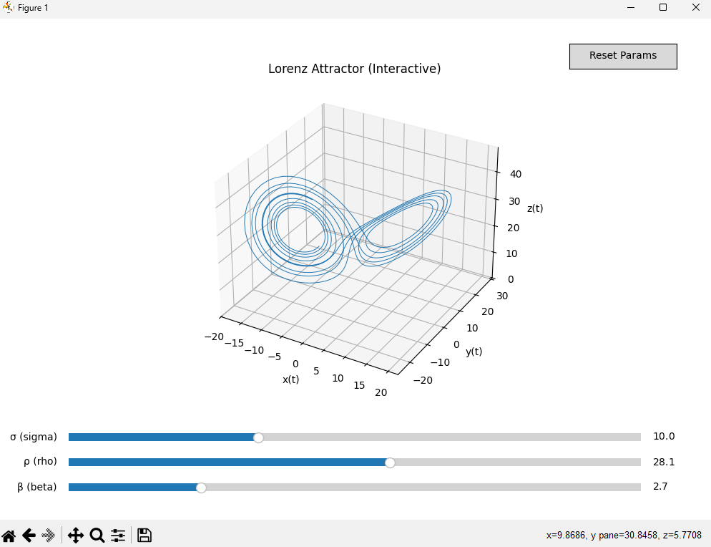

References
Core Lorenz System / Chaos Theory References
Lorenz, E. N. (1963). Deterministic nonperiodic flow. Journal of the Atmospheric Sciences, 20(2), 130–141.
https://doi.org/10.1175/1520-0469(1963)020<0130:DNF>2.0.CO;2
Strogatz, S. H. (2015). Nonlinear dynamics and chaos: With applications to physics, biology, chemistry, and engineering (2nd ed.). Westview Press.
Sparrow, C. (1982). The Lorenz equations: Bifurcations, chaos, and strange attractors. Springer.

Numerical Methods (Runge–Kutta / ODE Solvers)
Burden, R. L., & Faires, J. D. (2011). Numerical analysis (9th ed.). Brooks/Cole.
Python Libraries Used in Your Code
Harris, C. R., Millman, K. J., van der Walt, S. J., Gommers, R., Virtanen, P., Cournapeau, D., … & Oliphant, T. E. (2020).
Array programming with NumPy. Nature, 585, 357–362.
https://doi.org/10.1038/s41586-020-2649-2
Hunter, J. D. (2007). Matplotlib: A 2D graphics environment. Computing in Science & Engineering, 9(3), 90–95.
https://doi.org/10.1109/MCSE.2007.55

